Double Linked List

Push : Head, Tail, Mid

Pop : Head, Tail, Mid

* Head

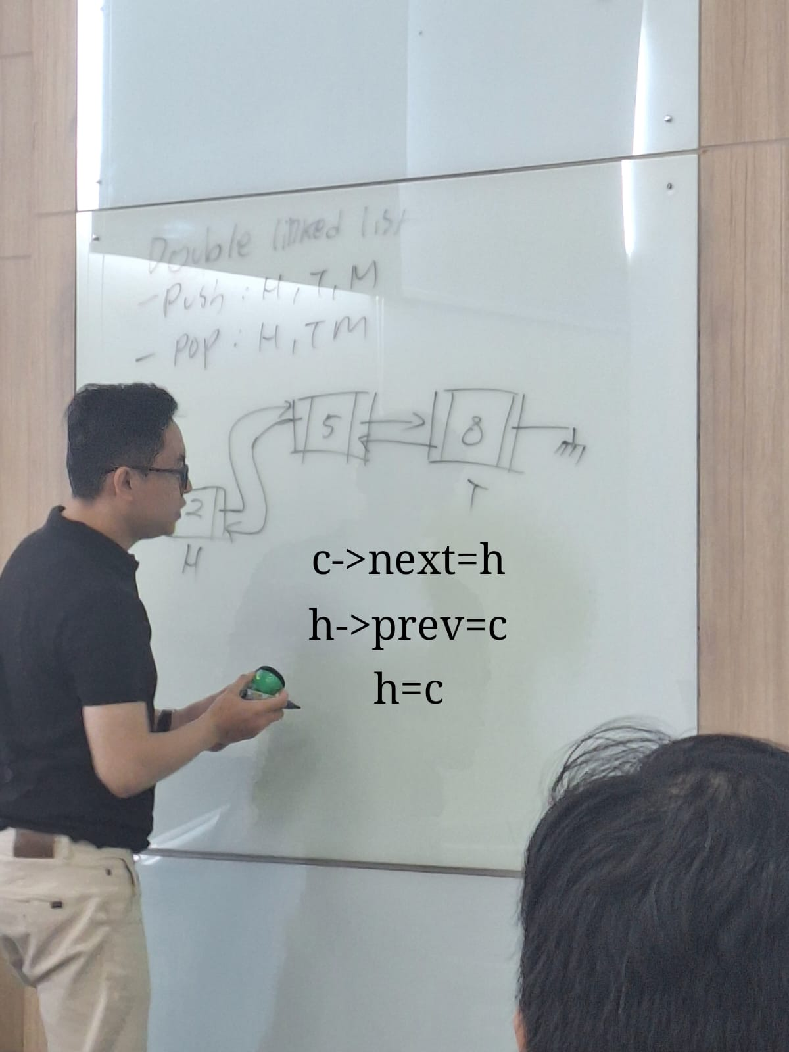

c->next = h

h->prev = c

h = c

* Tail

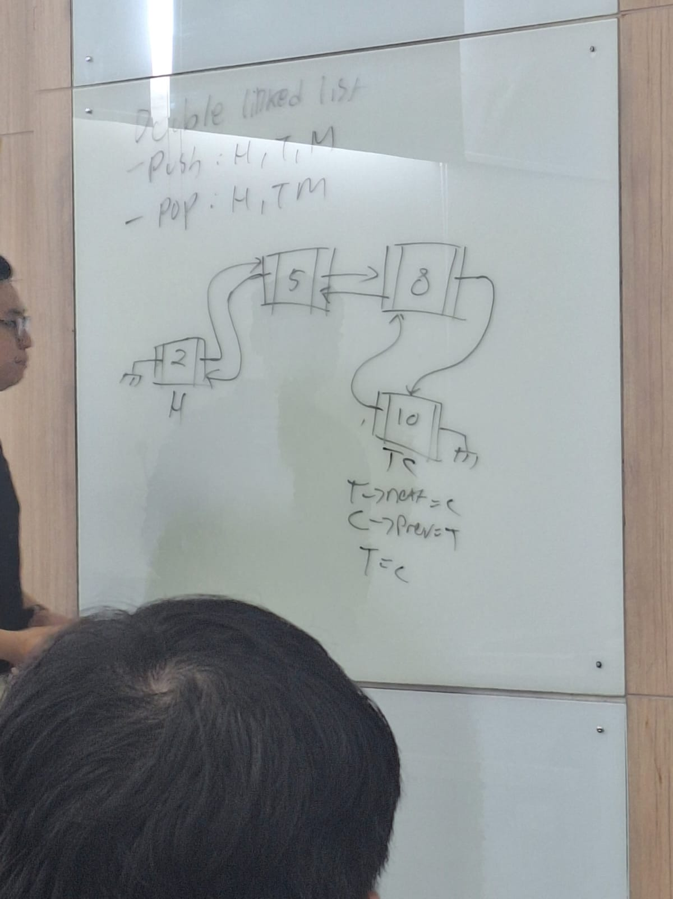

t->next = c

c->prev = t

T = C

* Mid

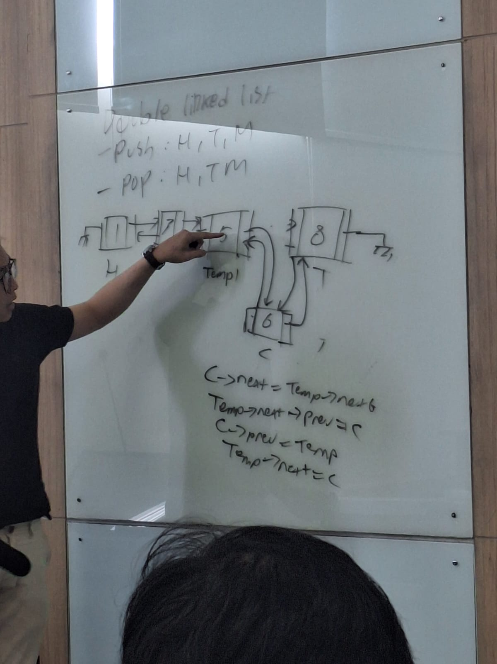

c->next = temp->next

temp-> next-> prev = c

c->prev = temp

temp->next = c

* Pop Head

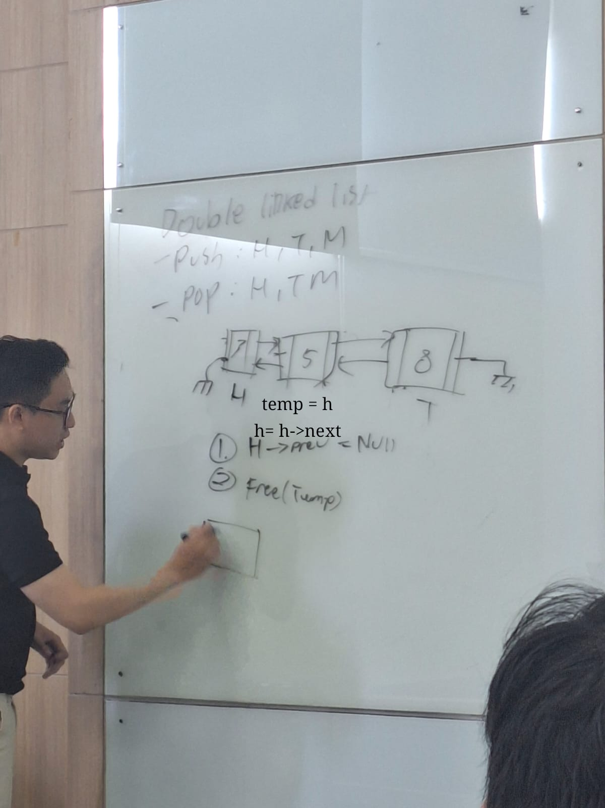

H-> = next = null

Free(temp)

* Pop Tail

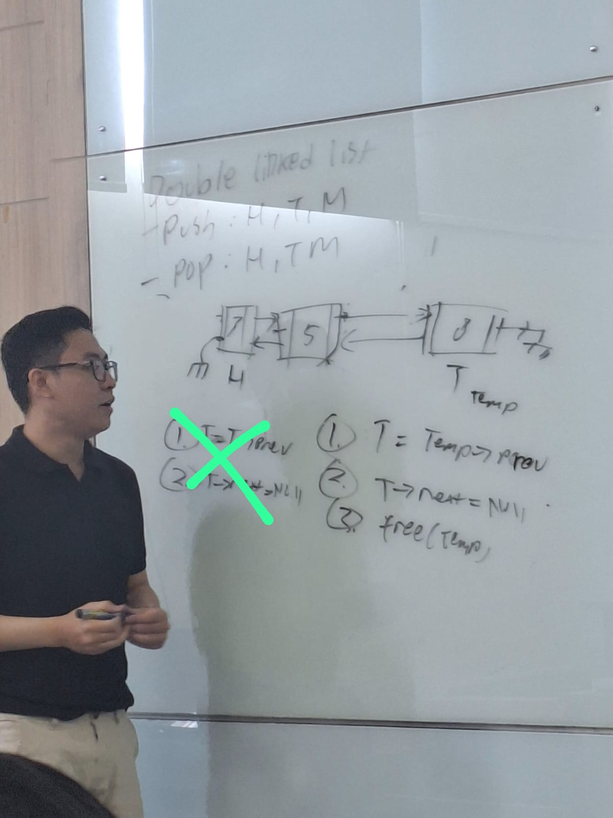

T = temp->prev / T = temp->prev

T->next = null

Free(temp)

* PopMid

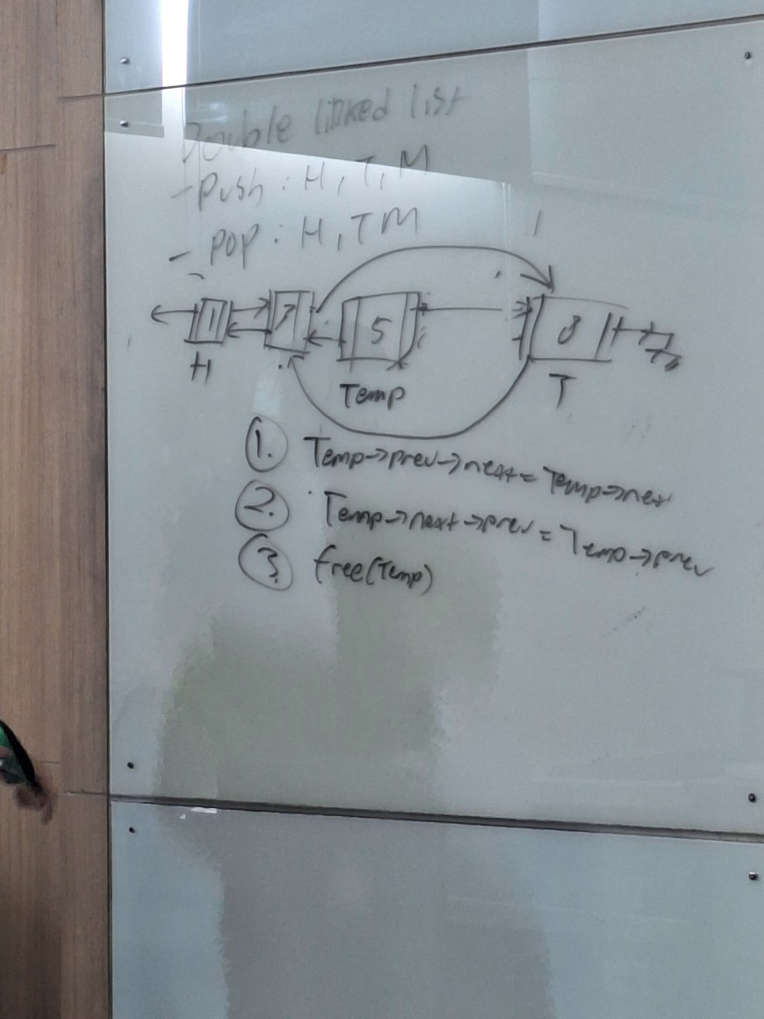

Temp->prev->next = temp->next

Temp->next->prev = temp ->prev

Free(temp)